**PROJECT :**

Product Demand Prediction with Machine Learning

**Phase 2 :**

Innovation

**SUBMITTED BY :**

Murali Keshava

au723921104024

[keshava33377@gmail.com](mailto:keshava33377@gmail.com)

Product Demand Prediction With Machine Learning

**EXPLANATION OF MY QUESTION:**

**1. Feature Engineering:**

**Develop relevant features like seasonality, promotions, economic indicators, and customer demographics to enhance prediction accuracy.**

**2.Hybrid Approach:**

**Combine traditional statistical methods like ARIMA with machine learning models to leverage their respective strengths for accurate predictions.**

**3. Real-time Data Integration:**

**Implement a system that continuously integrates real-time data to adapt the model and improve predictions as new information becomes available.**

**4. Customer Segmentation:**

**Divide customers into segments based on behavior, preferences, and purchasing history to predictions and** **marketing strategies for each segment.**

**5. Scalability and Deployment:**

**Design the system to be scalable, ensuring it can handle a growing volume of data and be easily deployed in various business environments.**

**6. User-Friendly Interface:**

**Develop an intuitive interface for users to interact with the prediction system, view insights, and customize parameters for personalized predictions.**

**ARCHITECTURE :**

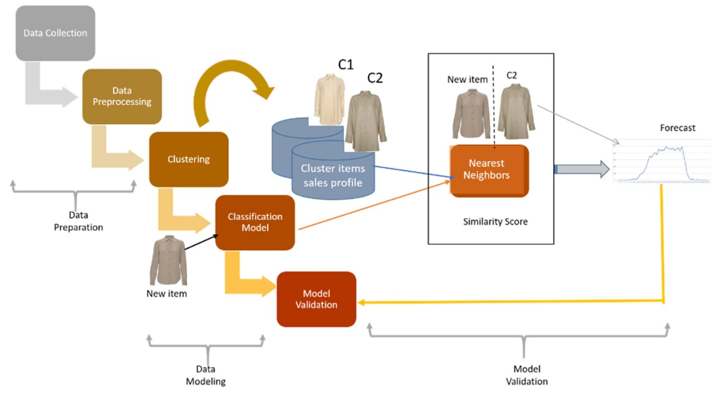

MACHINE ALGORITHMS :

N corporating machine learning algorithms plays a pivotal role in improving the accuracy of predictive models for product demand , specifically for predicting RSPM and PM10 levels. Machine learning techniques offer the capability to capture intricate relationships within the data, enhancing the precision and reliability of these predictions.

Linear Regression Predicts demand based on linear relationships between input features and demand. Time Series Analysis (e.g., ARIMA)Models demand patterns over time to predict future demand based on historical data Random Forest An ensemble learning method that can handle nonlinear relationships and capture complex patterns in the data Gradient Boosting (e.g., XGBoost, LightGBM) Boosting algorithms that improve prediction accuracy by building multiple weak models.

Neural Network Deep learning models can capture intricate patterns and relationships in the data, suitable for complex demand prediction tasks.

K-Nearest Neighbours (KNN) Predicts demand based on the behaviour of similar products or customers Support Vector Machines (SVM) useful for predicting demand when there's a clear margin of separation between different demand levels. Clustering Algorithms (e.g., K-means) group products based on similar demand patterns to make predictions for each group.

Recurrent Neural Networks (RNNs) effective for sequence-based data, like time series, to model temporal dependencies in demand. Long Short-Term Memory (LSTM) A type of RNN particularly useful for modeling long-term dependencies in time series data.

MACHINE LEARNING ALGORITHMS Used :

⮚ Linear Regression

⮚ Ploynomial Regression

⮚ XG Boost

⮚ Deep Learning

CONCLUSION:

**Conclusion leveraging machine learning for product demand prediction offers significant potential for businesses. By analyzing historical data and utilizing advanced algorithms, accurate demand forecasts can be generated, aiding in informed decision-making, optimized inventory management, and enhanced customer satisfaction. However, it's crucial to continually refine and update models, incorporate new data sources, and consider market dynamics to ensure the predictions remain reliable and effective in a dynamic business environment.**

